Clip Studio Paint – Key frame Animation

Set-up

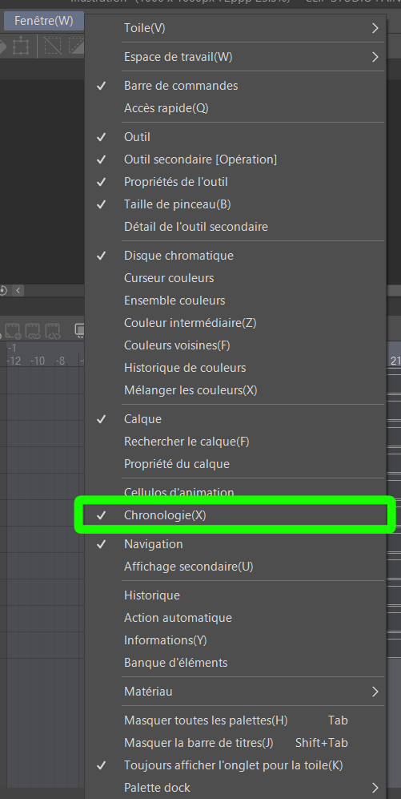
1 – Activate Timeline View
Turn on the timeline menu as seen in the image.

2 – Set Playback Options
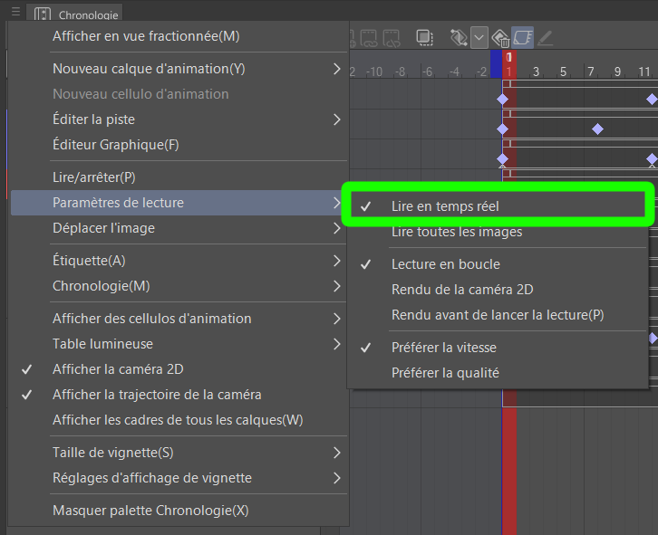
Via the three lines on the top left corner of the timeline menu, open parameters and make sure playback prioritises frame-rate accuracy over render quality – as per the image below.

3 – Check frame rate
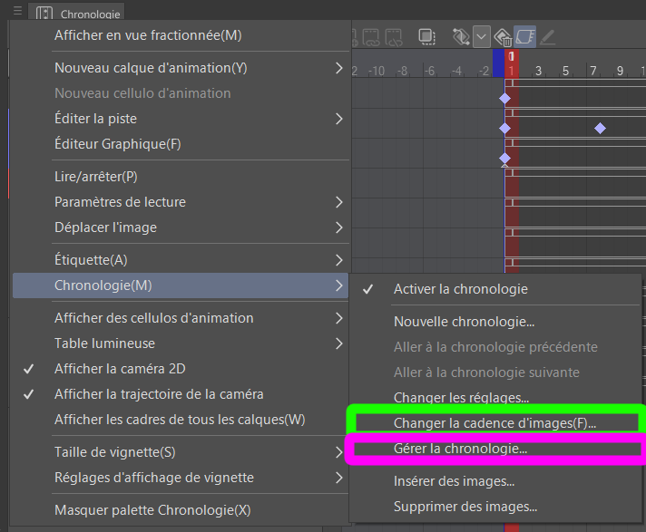
Still in the additional parameters drop-down menu, find your way to timeline parameters and check that FPS is set to 12.

4 – Duplicate blank template
If the art department did their job correctly, once in the “Manage timeline” menu you should see a Blank With PivotPoints timeline. Duplicate it.
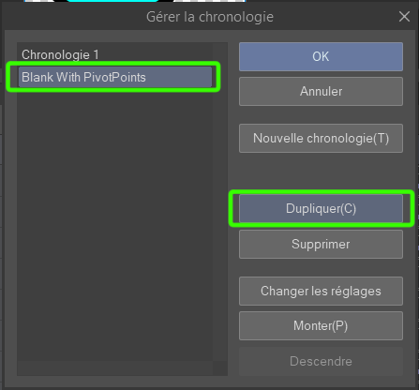
This timeline already has keyframes on frames 1 and 24, and the relevant layer’s pivot points have already been set-up.
If the Blank With PivotPoints template is missing, follow the guide at the end of this document to see how to create one.
If you are animating a sprite that uses duplicate animations from an already completed plant, request that the art department duplicate it if not already done.

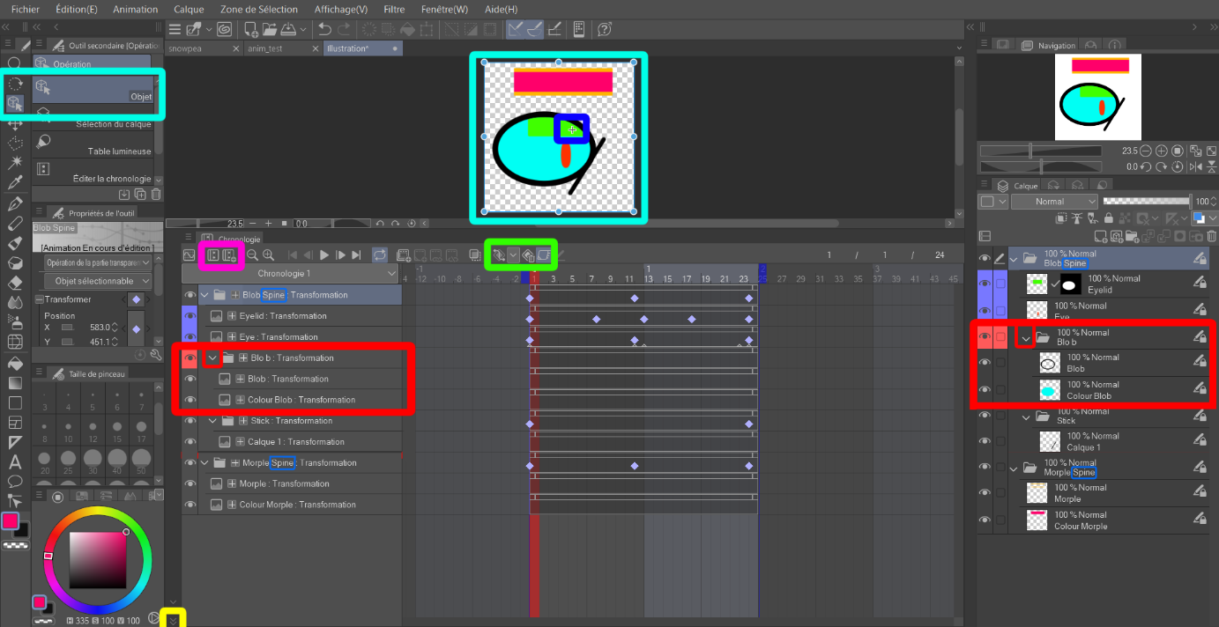
General Rules

1 – Timeline manipulation
In order to animate using keyframes, keyframe animation must be active. To do so, select every folder and click on the left-most button of the green rectangle in the middle of the image above.
If done correctly, the keyframes should now be visible.
To manipulate objects in this state, you must be in object mode (light blue rectangle on the left). This will enable the blue outline and anchor points for object manipulation (size and translation).
The pivot point is also visible in this state (dark blue rectangle in the middle of the canvas). It should not be touched, as it will mess it the centre of rotation and it does not carry through canvases. That is why it is already set up by the Blank With PivotPoints timeline.
You can collapse the timeline menu using the little arrows on the bottom left (yellow rectangle).

2 – Folders and Layers
While animating, you will only be using folders, not layers. In fact, all folders with no folders inside might as well be collapsed.
Folders marked in red shouldn’t be used during animation, they too can be collapsed.
On the other hand, blue layers may be used independently of folders during animation. This is notably used for pupils which can move by themselves, or eyelids which have masks and must therefore be moved by themselves.
Some folders are labelled “--- Spine”. These are the main bones, meaning everything that moves along with it – for instance all the facial features moving with the head – are inside that folder. This simulates the bone system you might find in other animation softwares.

3 – Creating a New Timeline
As explained above, the “create new timeline” button in the pink rectangle shouldn’t be used. Instead copy the blank template.

4 – Request assets from the Art Department
If you need assets for your animation, like new hand poses or in-between frames for rapid animations, inform the art department so that they can create the new sprites necessary ASAP.

Animating

1 – Creating and Duplicating Keyframes
All actions, be it changing the size, position or rotation will automatically create keyframes.
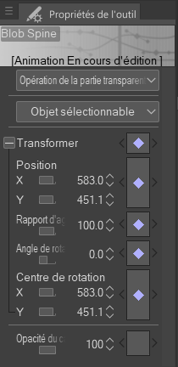
You can also create frames manually via the “create keyframe” and “delete keyframe” buttons also in the green rectangle. They always affect the frame you are currently on. Note keyframes appear on the right edge of the frame rather than the centre of it, as seen in the image above.
To duplicate existing frames, click and drag as if to move the frames but hold alt. A “+” icon will appear next to the ghost keyframe; this means it can be duplicated.
If there are no keyframes yet – such as with a new asset added after animation had begun – do not create it manually. Instead, create it as if you were to be making a Blank With PivotPoints timeline, as per the guide below.

2 – Hiding Layers
If you want to hide layers during the animation, you can’t simply use the eye icons next to the layers and folders.
Instead, you will use the opacity settings on the left menu.
Note that opacity has its own keyframes, which create small triangles instead of purple rhombuses, as seen in the image above in the Eye’s animation line.

Creating a Blank With PivotPoints Timeline

1 – Create a New Timeline
Start by creating a new timeline with the “Create Timeline” button and name it Blank With PivotPoints.

2 – Set up the Pivot Points
This new timeline should not have any keyframes on it. Do not add any manually.
Instead, select every relevant folder (non-red folders and blue layers) and set their pivot point. This is the small crosshair shown above in the dark blue rectangle.
It is the point from which the animation rotates. The reason it must be set up before adding keyframes is because its position can also be manipulated by keyframes, so rotations would become inconsistent and difficult to control.
Once all keyframes are created, select all frames, move them to frame 1 if not already there, then duplicate them to frame 24.
To easily select all layers, click-and-drag + alt from a point on the screen that has no keyframes. This will create a selection area.

3 – Duplicate the Blank With PivotPoints Timeline
Don’t forget to duplicate the blank timeline before animating.

